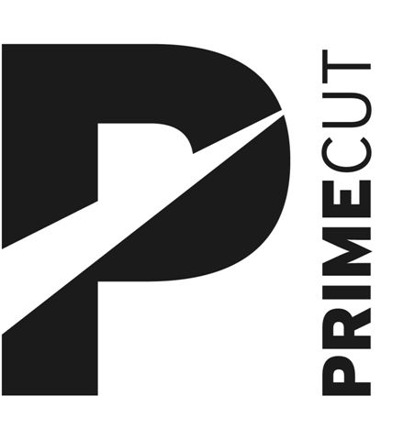

Biography
Una NicEoin – Prime Cut Executive Producer: Una has worked in the arts sector since 1992. After graduating from the University of Ulster she worked extensively as an actress and arts facilitator in Dublin.
In 1996, after relocating to Belfast, she took up position as Artist in Residence for Wheelworks.. Subsequently she worked as Tutor at the Centre for Performing Arts at Belfast Metropolitan College for four years before becoming Head of Education and Outreach at the Lyric Theatre, Belfast. In 2006 she became Creative Director at Creative Media Partnerships, developing and delivering a two year film project across the island of Ireland. In 2008 she became Arts Development Officer at Belfast City Council.
She became Executive Producer at Prime Cut Productions in 2009. Since then she has produced Scarborough for the Cathedral Quarter Arts Festival and Vincent River for Pride (2010) and Tour, Shoot The Crow Waterfront and NI Tour, Still Life Still: The Demeter Project at the Northern Bank, Belfast, Blackbird at the Lyric Naughton Studio and Tour, (2011) Shoot The Crow: Belfast Grand Opera House and Ireland wide tour, The Baths at Templemore Baths and I Am My Own Wife at The MAC (2012) Kaleidoscope -Belfast City Centre: Site Specific, The Conquest of Happiness for Derry-Londonderry City of Culture and European Tour, Tejas Verdes, Villa and Discurso at The MAC and An Culturlann Doire, Yasmina Reza’s The God of Carnage [co-production with The MAC]. Jack Thorne’s Mydidae (The MAC), Stacey Gregg’s Scorch (2015 Outburst Arts Festival: The MAC) Patrick Marber’s After Miss Julie (The MAC, The Project and island of Ireland Tour) Stacey Gregg’s multi-award winning Scorch for Edinburgh Fringe 2016, UK, Island of Ireland Tour and Sweden Tours, Adelaide Fringe 2017, Sociaetstheater, Dresden, Soho Theatre, London and British Council Showcase at Edinburgh Fringe 2017.) John Logan’s multi-award winning Red : (Lyric Belfast), Oona Doherty’s Hard To Be Soft (Belfast International Arts Festival, Dublin Dance Festival, Abbey Theatre, Recontres Choreographiques and Lyon Biennale) in 2017 and most recently the Prime Cut Edgefest Double Bill of Fintan Brady’s East Belfast Boy and John Patrick Higgins’ Every Day I Wake Up Hopeful for the MAC, Edinburgh Fringe 2018 and 2019 island of Ireland Tour.
Una has delivered presentations at a variety of conferences and events in Belfast, Galway, London, Sarajevo, Munich and Edinburgh for organisations that include Creative Europe and Theatre NI/Theatre Forum. She is a member of IETM. Una is also Chair of Ponydance Dance Company and an Artistic Associate of Streetwise Community Circus.

